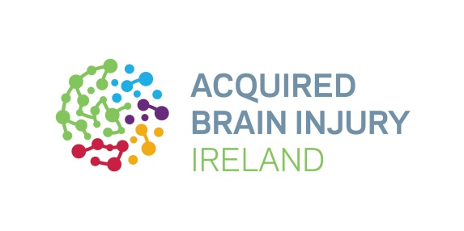

Acquired Brain Injury Ireland invites You to Raise Some Dough for Brain Injury Survivors This March

Join Acquired Brain Injury Ireland and ‘Bake for Brain Injury’ to make a life-changing difference to the 150,000 people living with a brain injury in Ireland.

5th March 2024: Get ready to raise some dough this March to support the work of Acquired Brain Injury Ireland (ABI Ireland) and help ‘bake’ the world a better place! ‘Room To Improve’ Star and Founder of Davey Nutrition, Daniel Davey and Football Legend, Paul McGrath will be taking on the baking challenge. Will you join them? Daniel Davey spoke about the importance of nutrition in supporting brain health and why he is taking part in ‘Bake For Brain Injury’:

‘I am delighted to support Acquired Brain Injury Ireland in their fundraising campaign 'Bake For Brain Injury' to raise awareness. Nourishing our bodies with the right food is not only essential for physical performance but also plays a crucial role in supporting brain function. Together we can encourage people to prioritise their health and contribute to a brighter, healthier future.’

Individuals, community groups, schools, businesses, families and friends across Ireland are invited to host their own ‘Bake for Brain Injury’ fundraising event at any point during the month.

‘Bake for Brain Injury’ is a hugely important event on the Acquired Brain Injury Ireland calendar, enabling the national organisation to raise vital funds to support survivors of brain injury as they work to rebuild their lives. It coincides with Brain Awareness Week, which takes place this year between 11th and 17th March – a global campaign to raise awareness and understanding of the brain and brain conditions, as well as the need for more investment in services, research and prevention. Former Ireland Footballer, Paul McGrath is looking forward to taking on another fundraiser for ABI Ireland:

‘I am excited to join Acquired Brain Injury Ireland for another fantastic fundraiser, sure it's always a no-brainer for me. I'm always reminded of the brilliant work they do whenever I visit their Wexford service. Taking part in fundraisers like Bake for Brain Injury is a way for me to support brain injury survivors and help them to get the services they need. It's also a chance for me to taste some home baking at the coffee day in Wexford!’

Every single year in Ireland, an estimated 19,000 people acquire a brain injury, resulting in life-altering, dramatic change. These injuries happen suddenly and are often traumatic, caused by road traffic accidents, stroke, assaults, concussion and viral infections like meningitis. Because each brain injury is unique, every survivor needs dedicated supports and a tailor-made rehabilitation plan.

Acquired Brain Injury Ireland offers the specialist care that they need. As Ireland’s leading provider of community neuro-rehabilitation for those ages 18 to 65, the organisation supports an estimated 1,100 people annually, as well as their families and carers. Interim Head of Fundraising, Marissa Tuccelli invites everyone to get involved and raise some dough:

‘This March we’re asking everyone to get behind brain injury survivors. Have a go at baking something new, treat others to your showstopper, or simply join a bake event with friends, family or colleagues. We want this year’s ‘Bake for Brain Injury’ fundraiser to be the most successful yet, so we encourage you to give what you can to help those impacted by brain injury to rebuild their lives.’

Find out more and register now to take part in ‘Bake for Brain Injury’ at abiireland.ie/Bake-For-Brain-Injury. Once registered, supporters will receive a special fundraising pack which includes the new Acquired Brain Injury Ireland apron to help you get your bake on. There is also guidance on how to start fundraising, online or in person.

Brain Awareness Week is a global campaign to foster public enthusiasm and support for brain science. Nationally the campaign is led by the Neurological Alliance of Ireland together with 30 member organisations, including Acquired Brain Injury Ireland.
For more information about Bake for Brain Injury and to register for all our events visit www.abiireland.ie

Further information

For further information about Bake for Brain Injury contact Matt Powell: mpowell@abiireland.ie / 086 410 3681

About Acquired Brain Injury Ireland

Acquired Brain Injury Ireland is an internationally accredited provider of community-based neuro-rehabilitation services for people with an acquired brain injury and their families. A brain injury can affect a person’s ability to manage their own life and Acquired Brain Injury Ireland works in communities across Ireland to support and empower people to rebuild their lives where they live. The not-for-profit organisation also campaigns, educates and advocates the rights and needs of this hidden group in society. www.abiireland.ie

About Brain Awareness Week 2024

Brain Awareness Week 2024 takes place from March 11th to 17th. National Brain Awareness Week is an annual initiative organised in March each year by the Neurological Alliance of Ireland to promote greater awareness and understanding of the impact of living with a neurological condition, as well as the need for investment in services, research and prevention. The week is supported by some 30 organisations and research groups in Ireland, including Acquired Brain Injury Ireland. www.nai.ie

